**Metholodogy of SDLC**

**Waterfall Model :**

The Waterfall Model was the first Process Model to be introduced. It is also referred to as a **linear-sequential life cycle model**. It is very simple to understand and use. In a waterfall model, each phase must be completed before the next phase can begin and there is no overlapping in the phases.

The Waterfall model is the earliest SDLC approach that was used for software development.

The waterfall Model illustrates the software development process in a linear sequential flow. This means that any phase in the development process begins only if the previous phase is complete. In this waterfall model, the phases do not overlap.

The Waterfall Model was the first Process Model to be introduced. It is also referred to as a **linear-sequential life cycle model**. It is very simple to understand and use. In a waterfall model, each phase must be completed before the next phase can begin and there is no overlapping in the phases.

The Waterfall model is the earliest SDLC approach that was used for software development.

The waterfall Model illustrates the software development process in a linear sequential flow. This means that any phase in the development process begins only if the previous phase is complete. In this waterfall model, the phases do not overlap.

**Waterfall Model – Design :**

Waterfall approach was first SDLC Model to be used widely in Software Engineering to ensure success of the project. In "The Waterfall" approach, the whole process of software development is divided into separate phases. In this Waterfall model, typically, the outcome of one phase acts as the input for the next phase sequentially.

The following illustration is a representation of the different phases of the Waterfall Model.

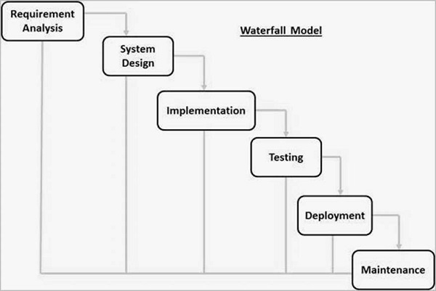

**SDLC V-Model – Software Engineering**

The V-model is a type of SDLC where the process executes sequentially in a V-shape. It is also known as the Verification and Validation model. It is based on the association of a testing phase for each corresponding development stage. The development of each step is directly associated with the testing phase. The next phase starts only after completion of the previous phase i.e., for each development activity, there is a testing activity corresponding to it.

**V-Model Design**

1. **Requirement gathering Analysis:** The first phase of the V-Model is the requirements gathering and analysis phase, where the customer’s requirements for the software are gathered and analyzed to determine the scope of the project.
2. **Design:** In the design phase, the software architecture and design are developed, including the high-level design and detailed design.
3. **Implementation:** In the implementation phase, the software is built based on the design.
4. **Testing:** In the testing phase, the software is tested to ensure that it meets the customer’s requirements and is of high quality.
5. **Deployment:** In the deployment phase, the software is deployed and put into use.
6. **Maintenance:** In the maintenance phase, the software is maintained to ensure that it continues to meet the customer’s needs and expectations.
7. **The V-Model is often used in safety:**critical systems, such as aerospace and defence systems, because of its emphasis on thorough testing and its ability to clearly define the steps involved in the software development process.

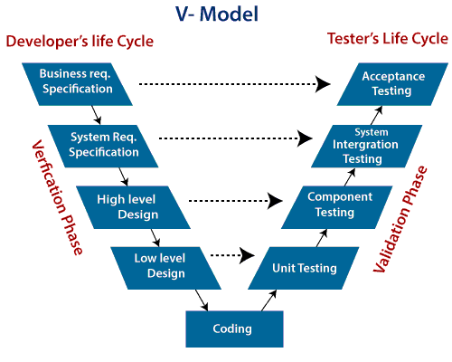

Agile Model

The meaning of Agile is swift or versatile."**Agile process model**" refers to a software development approach based on iterative development. Agile methods break tasks into smaller iterations, or parts do not directly involve long term planning. The project scope and requirements are laid down at the beginning of the development process. Plans regarding the number of iterations, the duration and the scope of each iteration are clearly defined in advance.

Each iteration is considered as a short time "frame" in the Agile process model, which typically lasts from one to four weeks. The division of the entire project into smaller parts helps to minimize the project risk and to reduce the overall project delivery time requirements. Each iteration involves a team working through a full software development life cycle including planning, requirements analysis, design, coding, and testing before a working product is demonstrated to the client.

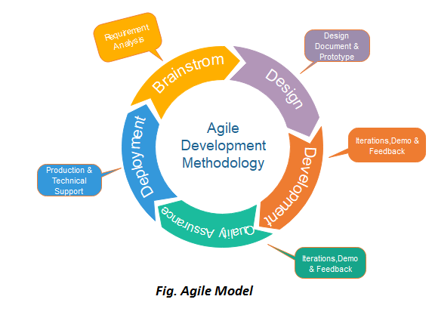

Phases of Agile Model:

Following are the phases in the Agile model are as follows:

1. Requirements gathering
2. Design the requirements
3. Construction/ iteration
4. Testing/ Quality assurance
5. Deployment
6. Feedback

**1. Requirements gathering:** In this phase, you must define the requirements. You should explain business opportunities and plan the time and effort needed to build the project. Based on this information, you can evaluate technical and economic feasibility.

**2. Design the requirements:** When you have identified the project, work with stakeholders to define requirements. You can use the user flow diagram or the high-level UML diagram to show the work of new features and show how it will apply to your existing system.

**3. Construction/ iteration:** When the team defines the requirements, the work begins. Designers and developers start working on their project, which aims to deploy a working product. The product will undergo various stages of improvement, so it includes simple, minimal functionality.

**4. Testing:** In this phase, the Quality Assurance team examines the product's performance and looks for the bug.

**5. Deployment:** In this phase, the team issues a product for the user's work environment.

**6. Feedback:** After releasing the product, the last step is feedback. In this, the team receives feedback about the product and works through the feedback.